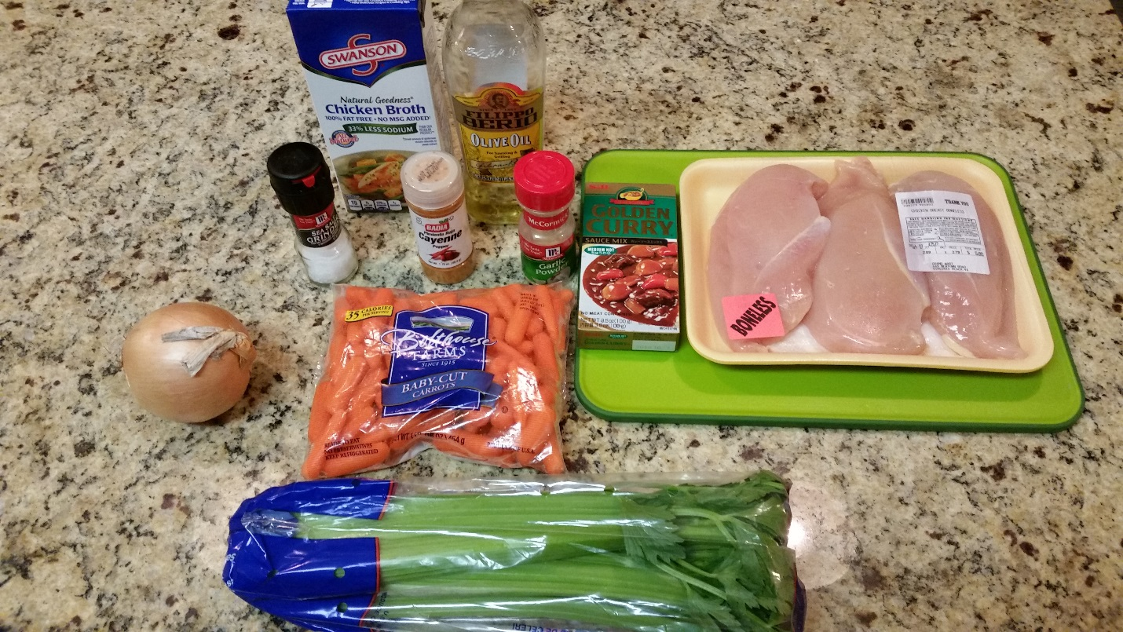

1 box of S&B Golden Curry. You only need a small one it will be vertical not horizontal. They have mild, medium, medium hot and hot. I recommend either mild or medium if people are not used to it. NOT HOT.
1 Large Sweet Onion (Vidalia or Spanish)
1 pound bag of carrots
1 celery head
3+ boneless, skinless, chicken breasts
Olive oil
2 cups Chicken Broth
Seasonings as desired. I have Salt, Cayenne Pepper, and Garlic Powder pictured

Trim all fat off of breasts.
Slice breasts in half, lengthwise (not optional), place between cling wrap and pound (optional)
Slice breast crosswise, thinly into strips.
Start your rice in the rice cooker.
Chop onions, (slices or small pieces, doesn't matter)
Rinse off carrots and celery in the sink.
Slice carrots and celery, the thinner the slices, the more quickly they cook and more tender they will be.
Place onions and chicken in olive oil with a little butter in the bottom of a pot enough to cook the onions and chicken. Cook onions and chicken until chicken is approx. 10 minutes at Medium High. Some will be brown and some will be white, but don't burn.
Add 2 cups chicken broth simmer to slight boil. While this is simmering, cut up the block of curry. Slice thinly. Lower heat to low and dissolve the curry in the hot broth. Make sure you stir it to get out the clumps, if it is too thick, add more chicken broth.
As soon as the curry is dissolved, add all of the chopped celery and carrots into the pot, cover and cook covered, low heat for about 20-25 minutes, stirring occasionally. If the carrots and celery are thin, 20 minutes should do it, if you like them firm, then 15. Use your judgement.
Add seasoning as desired
You don't want the bottom of the pot to burn so don't forget to stir.
Serve over white rice!!

Total Time: ~1.25 hr for 1 person to prep and cook
Total Cost: $17 (and you’ll have extra olive oil, extra broth, extra carrots, extra onion)
Total fed: ~4 growing boys or ~Family of 6

